SYSTEMS DIVISION

IPD Consolidated Series
Test Plan
(for IPD Data Warehouse Load, Phase 2)
TEST PLAN DOCUMENT
Version 5.2.37.1

DRAFT

Prepared By:
Back Office IPD Team

1 Regression Testing 3
2 Test Class_Adj_Daily load. 3
3 Test Class_Hist_Daily load 3
4 Test Series_Adj_Daily load 4
5 Test Series_Daily load 4
6 Test Undly_Inst_Hist load 5
7 SAS CLASS FILE CREATION Test 6
8 PDS FILE CREATION Test 8
9 OCC FILE AND REPORT CREATION Test 10
10 OCC sc0131 report generation 12
11 QPE2 flag 14
12 Validation Changes for Weekly Option Series 14

Regression Testing

Regression testing of IPD application using test plans from all earlier versions

Test Class_Adj_Daily load.

Run batch job.
- Use Control-M class_adj_daily in BOS_IPD.
- At Unix command line in IPD run_dir/bin, run class_adj_daily.sh

Check script result. If running at the command line, you should see the message “Finished successfully” followed by the system time. In Control-M, the job status will turn green.

Verify the results. Open a sqlplus prompt (type loginDb) and do the following steps.

Verify the count by running this SQL. The count should not be zero. Roughly 4,000 records are expected.
select count(*) from class_adj_daily

Verify the run time by running the following SQL. The run time should be roughly the same as the job execution time.
select to_char(ipd_download_time, 'mm/dd/yyyy hh24:mi:ss')
from class_adj_daily
where rownum = 1

Test Class_Hist_Daily load

Run batch job.
- Use Control-M class_hist_daily in BOS_IPD.
- At Unix command line in IPD run_dir/bin, run class_ hist_daily.sh

Check script result. If running at the command line, you should see the message “Finished successfully” followed by the system time. In Control-M, the job status will turn green.

Verify the results. Open a sqlplus prompt (type loginDb) and do the following steps. Approve adjustment.

Verify the count by running this SQL. The count should not be zero. Roughly 4,000 records are expected.
select count(*) from class_hist_daily

Verify the run time by running the following SQL. The run time should be roughly the same as the job execution time.
select to_char(ipd_download_time, 'mm/dd/yyyy hh24:mi:ss')
from class_hist_daily
where rownum = 1

Test Series_Adj_Daily load

Run batch job.
- Use Control-M series_adj_daily in BOS_IPD.
- At Unix command line in IPD run_dir/bin, run series_adj_daily.sh

Check script result. If running at the command line, you should see the message “Finished successfully” followed by the system time. In Control-M, the job status will turn green.

Verify the results. Open a sqlplus prompt (type loginDb) and do the following steps.

Verify the count by running this SQL. The count should not be zero. Between 120,000 and 150,000 records are expected.
select count(*) from series_adj_daily

Verify the run time by running the following SQL. The run time should be roughly the same as the job execution time.
select to_char(ipd_download_time, 'mm/dd/yyyy hh24:mi:ss')
from series_adj_daily
where rownum = 1

Test Series_Daily load

Run batch job.
- Use Control-M series_daily in BOS_IPD.
- At Unix command line in IPD run_dir/bin, run series_daily.sh

Check script result. If running at the command line, you should see the message “Finished successfully” followed by the system time. In Control-M, the job status will turn green.

Verify the results. Open a sqlplus prompt (type loginDb) and do the following steps.

Verify the count by running this SQL. The count should not be zero. Between 120,000 and 150,000 records are expected.
select count(*) from series_daily

Verify the run time by running the following SQL. The run time should be roughly the same as the job execution time.
select to_char(ipd_download_time, 'mm/dd/yyyy hh24:mi:ss')
from series_daily
where rownum = 1

Test Undly_Inst_Hist load

Run batch job.
- Use Control-M undly_inst_daily in BOS_IPD.
- At Unix command line in IPD run_dir/bin, run undly_inst_daily.sh

Check script result. If running at the command line, you should see the message “Finished successfully” followed by the system time. In Control-M, the job status will turn green.

Verify the results. Open a sqlplus prompt (type loginDb) and do the following steps.

Verify the count by running this SQL. The count should not be zero. Between 1,500 and 2,200 records are expected.
select count(*) from undly_inst_daily

Verify the run time by running the following SQL. The run time should be roughly the same as the job execution time.
select to_char(ipd_download_time, 'mm/dd/yyyy hh24:mi:ss')
from undly_inst_daily
where rownum = 1

SAS CLASS FILE CREATION Test

SAS Class File Creation Test

Test Description:
The SAS Class file to be reconciled resides on the MVS system. It should be copied to DASD for the verification. The DSN is BACKUP.TM.CLASS(0) or whatever generation is appropriate. The tester will need an MVS logon to do this.
The following script will be used to create the SAS Class extract file: createSasClassFile. The series file FTPd to MVS is TS333ID.BACKUP.TM.CLASS

Test Environment
IPD and ipdsd000 and MVS.

Expected Results
- Compare is TS333ID.BACKUP.TM.CLASS with is BACKUP.TM.CLASS(0) or whatever generation is appropriate. The data content should be identical.

Actual Results
The data in the MVS files.
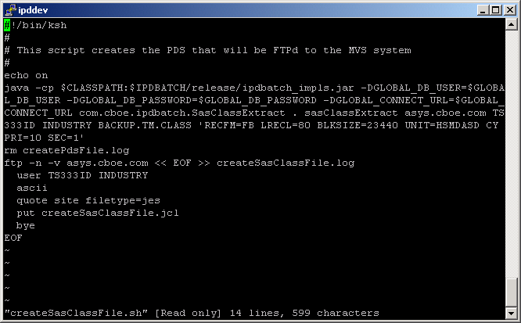
This is the unix script createSasClassFile.sh. The default next trading day is obtained from the This script will create the unix file sasClassExtract that will be FTPd to MVS with the name TS333ID.BACKUP.TM.CLASS.

PDS FILE CREATION Test

PDS File Creation Test

Test Description:
The PDS file to be reconciled resides on the MVS system. It should be copied to DASD for the verification. The DSN is CBOE.SC.SRTDTSS.SERIES(0) or whatever generation is appropriate. The tester will need an MVS logon to do this. Even if IPD is reconciled to TPF there may be manual changes from TPF that are reflected in the production PDS file such as changes to reporting classes and extra deletes.
The following script will be used to create the PDS series file: createPdsFile. The series file FTPd to MVS is TS333ID.CBOE.SC.SRTDTSS.SERIES. If the next trading day desired is not the one on the table bus_day an extra program parameter can be added at the end of the execution line in the form YYMMDD (i.e. 050823) so that the proper day can be processed and the results compared against the production copy.

Test Environment
IPD and ipdsd000 and MVS.

Expected Results
- Compare is TS333ID.CBOE.SC.SRTDTSS.SERIES with is CBOE.SC.SRTDTSS.SERIES(0) or whatever generation is appropriate. These files should be identical.

Actual Results
The data in the MVS files.
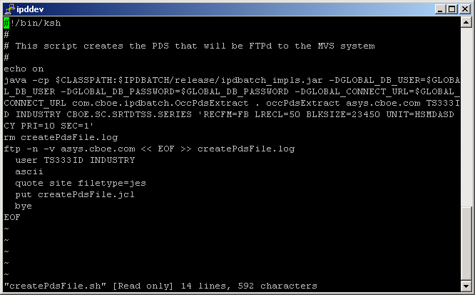

This is the unix script createPdsFile.sh. The default next trading day is obtained from the table bus_day. If another trading day is needed it can be added to the end of the execution line in YYMMDD format, for example 050823. This script will create the unix file occPdsExtract that will be FTPd to MVS with the names TS333ID.CBOE.SC.STRDTSS.SERIES.

OCC FILE AND REPORT CREATION Test

OCC File and Report Creation Test

Test Description:
The OCC files to be reconciled reside on the MVS system on tape. They should be copied to DASD for the verification. The DSNs are CBOE.OCC.AS.ADDRECS(n) and CBOE.OCC.AS.ADDRECS(n –1) where n is the generation for the after split process and n –1 is the generation for the before split process for the trading day to be verified. The tester will need an MVS logon to do this. Infopac is used to verify the as0800 reports. Infopac may be gotten to by http://infopacnt on the browser or INFO using Mocha or some other mainframe login software.
The pre-adjustment verification is as follows:
The following script will be used to create the OCC series file and report file: createOccFileBeforeAdj. The series file FTPd to MVS is RJE.UNIX.IPD.OCC.SERIES.BEFORE.ADJ. The series report file FTPd to MVS is RJE.UNIX.IPD.OCC.SERIES.BEFORE.ADJ.REPORT. This script will be run for a particular next trading day. If the next trading day desired is not the one on the table bus_day an extra program parameter can be added at the end of the execution line in the form DD-MM-YYYY (i.e. 23-08-2005) so that the proper day can be processed and the results compared against the production copies and infopac reports for that day. This reconciliation is verified the Daily excel spreadsheet against CBOE.OCC.AS.ADDRECS(n –1: usually –1) and the corresponding report on Infopac.
The post-adjustment verification is as follows:
The following script will be used to create the OCC series file and report file: createOccFileAfterAdj. The series file FTPd to MVS is RJE.UNIX.IPD.OCC.SERIES.AFTER.ADJ. The series report file FTPd to MVS is RJE.UNIX.IPD.OCC.SERIES.AFTER.ADJ.REPORT. This script will be run for a particular next trading day. If the next trading day desired is not the one on the table bus_day an extra program parameter can be added at the end of the execution line in the form DD-MM-YYYY (i.e. 23-08-2005) so that the proper day can be processed and the results compared against the production copies and infopac reports for that day. This reconciliation is verified the Daily excel spreadsheet against CBOE.OCC.AS.ADDRECS(n: usually 0 ) and the corresponding report on Infopac.

Test Environment
IPD and ipdsd000 and MVS.

Expected Results
- Compare RJE.UNIX.IPD.OCC.SERIES.BEFORE.ADJ with CBOE.OCC.AS.ADDRECS(n –1). There should be no differences.
- Compare RJE.UNIX.IPD.OCC.SERIES.BEFORE.ADJ.REPORT with the appropriate as0800 report on infopac. There should be no differences. RJE.UNIX.IPD.OCC.SERIES.BEFORE.ADJ.REPORT is a report format of RJE.UNIX.IPD.OCC.SERIES.BEFORE.ADJ.
- Compare RJE.UNIX.IPD.OCC.SERIES.AFTER.ADJ with CBOE.OCC.AS.ADDRECS(n ). There should be no differences.
- Compare RJE.UNIX.IPD.OCC.SERIES.AFTER.ADJ.REPORT with the appropriate as0800 report on infopac. There should be no differences. RJE.UNIX.IPD.OCC.SERIES.AFTER.ADJ.REPORT is a report format of RJE.UNIX.IPD.OCC.SERIES.AFTER.ADJ.

Actual Results
The data in the MVS files and infopac reports.

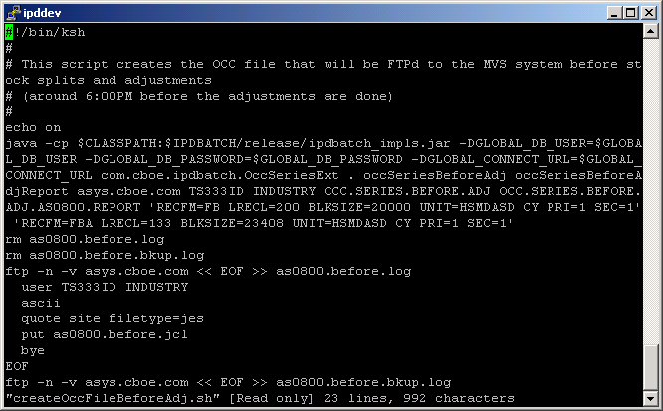
This is the unix script createOccFileBeforeAdj.sh before adjustments. The default next trading day is obtained from the table bus_day. If another trading day is needed it can be added to the end of the execution line in DD-MM-YYYY format, for example 23-08-2005. This script will create the unix files occSeriesBeforeAdj and occSeriesBeforeAdjReport that will be FTPd to MVS with the names TS333ID.SERIES.BEFORE.ADJ and TS333ID.SERIES.BEFORE.ADJ.AS0800.REPORT. A similar test can be done for createOccFileAfterAdj.sh after adjustments.

OCC sc0131 report generation

OCC sc0131 report generation

Test Description:
This test will verify the MVS file created by the occCreateReport.sh script against the infopac report sc0131.

Test Environment
IPD and ipdsd000 and MVS. Test after the first test is complete

Expected Results
- Compare RJE.UNIX.IPD.OCC.SERIES.SC0131.REPORT with the appropriate sc0131 report on infopac. The only differences should be manual changed made through the TPF screens. Check with the users to verify that these changes were actually made. These changes should parallel the OCC file changes.

Actual Results
The data in the MVS file and infopac report.

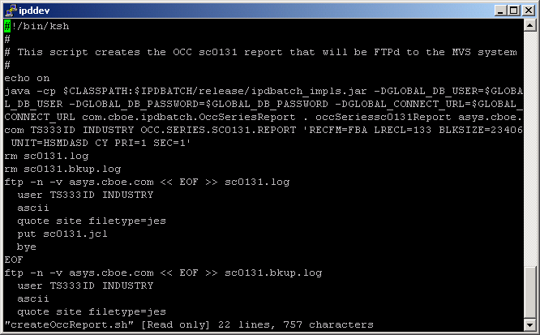

This is the unix script createOccReport.sh. The default next trading day is obtained from the table bus_day. If another trading day is needed it can be added to the end of the execution line in DD-MM-YYYY format, for example 23-08-2005. This script will create the unix file occSeriessc0131Report that will be FTPd to MVS with the name RJE.UNIX.IPD.OCC.SERIES.SC0131.REPORT.

QPE2 flag

QPE2 flag automatically set for hybrid classes (no QPE2 indicator on gui)

Validation Changes for Weekly Option Series

Users should be able to enter any valid future business date as the expiration date for weekly option series.

